# File permissions in Linux

## Project description

In this module I learned how to perform various tasks such as navigating the file system, listing directory contents, examining file contents, moving and copying files, changing file permissions, and combining commands to manipulate data efficiently.

## Check file and directory details

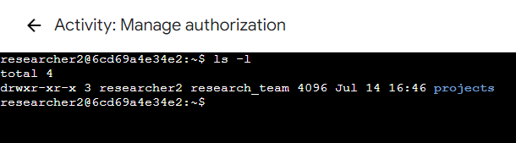

## Describe the permissions string

For example, a permissions string of "drwxr-xr-x" indicates a directory with read, write, and execute permissions for the owner, and read and execute permissions for both the group and others.

## Change file permissions

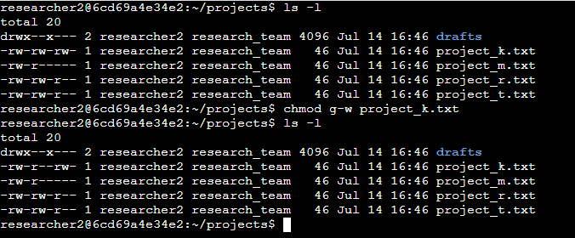

## Change file permissions on a hidden file

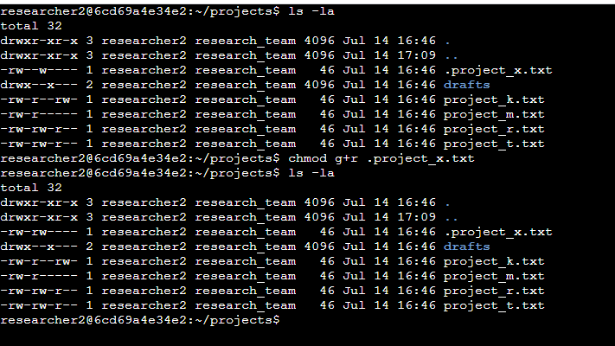

## Change directory permissions

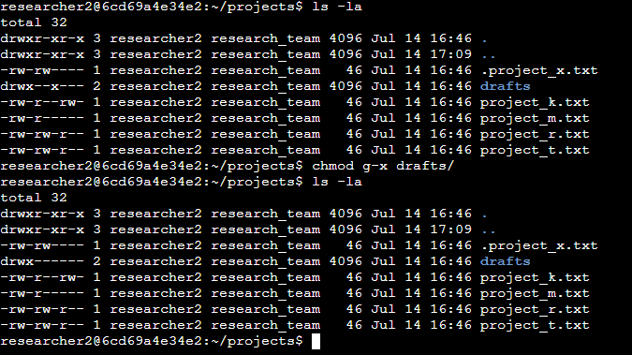

## Summary

Through this assignment, I have acquired the skills to navigate the file system effortlessly, list directory contents, view the contents of files, and execute moves and copies of files. Furthermore, I have gained the ability to modify permissions for files and directories, customizing access according to my specific requirements. Additionally, I have discovered the power of combining commands through piping, enabling me to perform complex operations and manipulate data effectively. These newfound skills have empowered me to take complete control of file management, directory organization, and data manipulation in a Linux environment. I am now equipped with a solid foundation to tackle diverse tasks and handle various scenarios with confidence.